Assignment 8 Solutions

1. An adsorption study was conducted by adding varying amounts of activated carbon to a series of seven flasks containing 500mL of feed water used in soft drink preparation having an initial TOC of 2.0mg/L. The flasks were agitated for 14h, and the residual, steady-state TOC concentrations were determined. Plot the Langmuir and Freundlich isotherms for the data presented below and determine the values of the appropriate constants. Only hand in one of the isotherms.

Flask No. Carbon Dosage (mg) Final TOC (mg/L)

1 0 2.0
2 4.4 1.7
3 9.7 1.4
4 14 1.2
5 28 1.0
6 56 0.9
7 140 0.8
(Tip: Find the non-adsorbable fraction of the TOC. As this does not participate in any way to the adsorption, its value should be disregarded, i.e. subtracted from the TOC to leave an adsorbable dissolved organic carbon, ADOC, which may then fit the adsorption models better.)

Solution
Langmuir isotherm
- Calculate the values of x and x/m from the data, e.g. for flask 1:
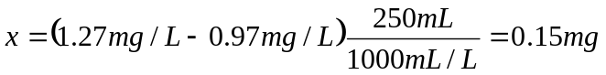
Assume the non-absorbable TOC is 0.73 mg/L (from a linear extrapolation)
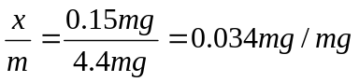
Flask No. | Carbon Dosage (mg) | Initial ATOC (mg/L) | Final ATOC (mg/L) (C) | Mass of Adsorbate Adsorbed (mg) (x) | x/m (mg/mg) | 1/C | 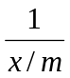
1 | 0 | 1.27 | 1.27 | 0.00 | 0.000
2 | 4.4 | 1.27 | 0.97 | 0.15 | 0.034 | 1.031 | 29.333
3 | 9.7 | 1.27 | 0.67 | 0.30 | 0.031 | 1.493 | 32.333
4 | 14 | 1.27 | 0.47 | 0.40 | 0.029 | 2.128 | 35.000
5 | 28 | 1.27 | 0.27 | 0.50 | 0.018 | 3.704 | 56.000
6 | 56 | 1.27 | 0.17 | 0.55 | 0.010 | 5.882 | 101.818
7 | 140 | 1.27 | 0.07 | 0.60 | 0.004 | 14.286 | 233.333

- Plot values of 1/C vs. 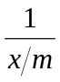 as shown in Figure 2.
- Determine the values of the constants a and b.
Read value of intercept 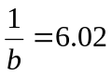, 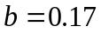
Slope 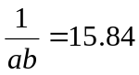, 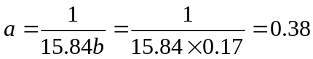
- The Langmuir equation is
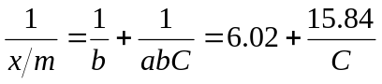
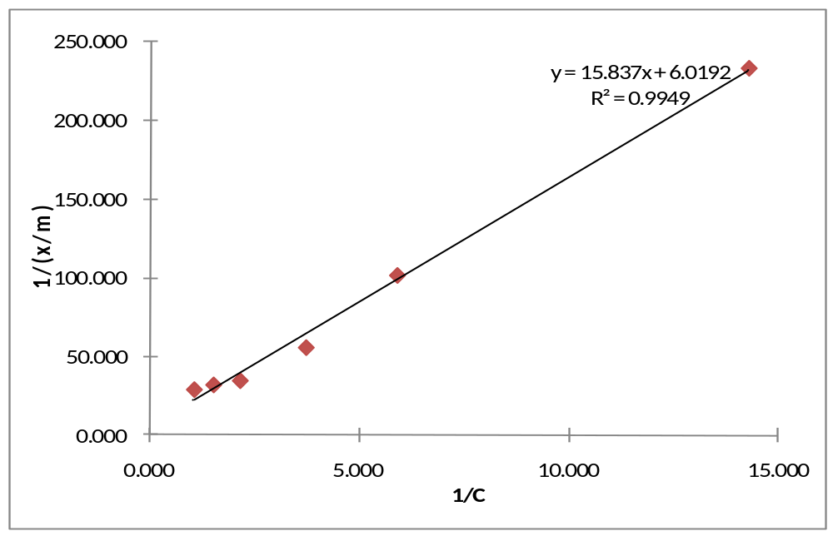
Figure 1 Plot of Langmuir isotherm

Note: The non-adsorbable value should be a bit lower than 0.8. If you choose 0.8, the graph will move horizontally between the two first (left) two points. Also, physically speaking, it should be a bit lower than 0.8 as we have not applied such a huge dosage yet, and larger dosages would result in a TOC < 0.8..

2. The Freundlich isotherm can be accepted to represent equilibrium concentrations of phenol in the μg/L concentration range and x/m represents μg phenol/mg C.
a) If the limiting concentration of phenol is set at 0.2μg/L and the source contains 30μg/L, calculate the required dosage of powdered activated carbon.
b) If instead of a single dosage, the carbon was dosed twice, first to achieve a concentration of 3μg/L and then in a second tank to the final requirement, how much carbon will be required?
c) How could we minimize carbon requirements over two dosages?
d) Qualitatively consider the effect of even more tanks and possibilities of reusing the carbon from tank to tank. The isotherm may be extrapolated.

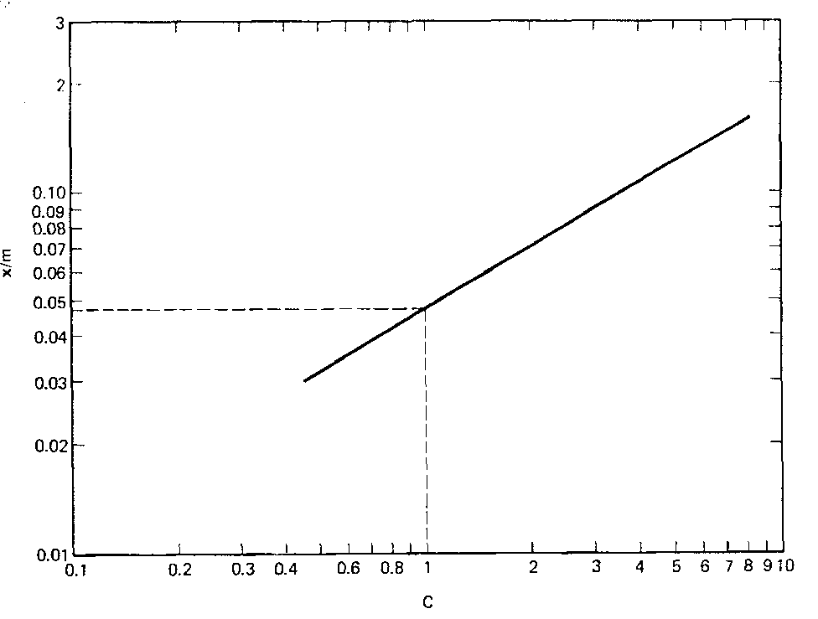

Figure: Freundlich isotherm for Problem 2

Solution
a) According to the graph, when c = 0.2g/L, x/m = 0.019, assuming 1L phenol solution:
b) According to the graph, when c = 3g/L, x/m = 0.089, assuming 1L phenol solution:
According to the graph, when c = 0.2g/L, x/m = 0.019, assuming 1L phenol solution: So, the total carbon required is: 303.4 mgC+147.4 mgC = 450.8 mgC

c) In order to minimize the carbon usage over two dosages, a concentration of the effluent of phenol from the first activated carbon dosage must be determined. If this concentration is too close to the initial phenol concentration, the dosage used in the second step will be decreased while that used in the first step will be increased, and vice versa. More elegantly, write and equation of C as a function of PAC dose, differentiate and solve when = 0. PAC dosages of about 160 mg/L each will represent the lowest dosage for a two-step process.

d) The total dosage needed will decrease with an increase of tanks. If the carbon from the last step is recycled towards the first tank, countercurrent to the water flow, the adsorption capacity of carbon can be maximized and minimize the carbon requirement even further. You can see that the PAC from the last step above would have much adsorption capacity left when reused in the first tank.

3. A laboratory column 10cm in diameter and 3m deep, is found to produce good results in COD removal when operated at a flow of 50L/h. Calculate the following:
a. The application rate in m/h.
b. The residence time, t, in the column.
c. The volumetric flow rate, Vb, in bed volumes per hour, for this residence time.
d. You need to design a GAC system consisting of two columns in series for treating the same water at a rate of 0.5 ML/d. Practical considerations limit the diameter of the columns to 3m. Calculate the required height of the columns allowing for sufficient backwash space.

Solution
- The section area A = 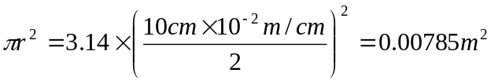
Volume of GAC = 3m x 0.00785 = 0.02355 m³
The application rate or approach velocity 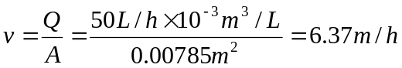
b) The residence time t = 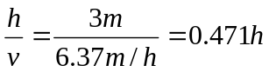
c) Assume the fractional void volumes for granular carbon columns is 0.5 (normally range from 0.40 to 0.55)
Volumetric flow rate = 1/residence time = 1/0.471 = 2.12 bed volumes/h
d) 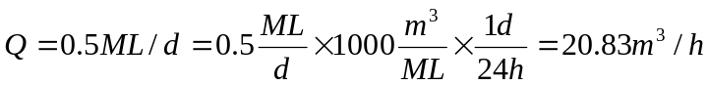
The volume of the GAC in the columns has to be
The required sectional area of the column is calculated from the approach velocity:
A = 20.83/6.37 = 3.27 m², i.e 2m diameter
The height of GAC in each column has to be 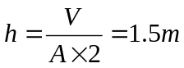
Assume backwash space 50% (typical value is 20~50%)
The height for each column then has to be 2.25m.
Note: The loading rate on pilot scale was low. We might want to work at 10-20 m/h.

4. Water, following conventional treatment and chlorination, contains 100 μg/L chloroform. This exceeds permissible levels and you need to check the implications of using GAC to keep this below 50 μg/L. Estimate the bed life and carbon usage rate. Comment on the suitability of GAC for this purpose.

According to Table 14-2: K = 0.0925 (mg/g) (L/μg)^{1/n}, i.e. 1/n = 0.67

Using Freundlich: (q_{c})₀ = 0.0925 (mg/g)(L/μg)^{0.669} x (100 μg/L)^{0.67} = 2.0 mg/g

Eq 14-20: Y = [(q_{e})₀ / (C₀-C₁)] x ρ = 2.0 / (0.1 -0.05) x 500 kg/m³ = 20,000 m³/m³ = bed capacity

A typical bed capacity of 15 minutes would then have a life of 20,000/(24x4) = 208 days.

Find carbon utilization rate from 14-21: CUR = (C₀ – C₁)/q_{e0} = 0.05/2 = 0.025 kg GAC/ m³ water

GAC suitability Practical limitation will be competition. The adsorbability of chloroform is poor compared with most other substances, so GAC life may be much more limiting. Furthermore, chloroform is poorly biodegradable. There is a need to keep chloroform low. Adapting pretreatment and disinfection practices to minimize formation of chloroform is better, but GAC can play a role, if not a very effective one, to keep this DBP to an acceptable level.

